|  |  |
| --- | --- |
| Date | 18 Oct 2023 |
| Team id | Proj-212175-Team 2 |
| Project Name | Chatbot using python |
| Maximum mark |  |

PHASE 3

Data visualizatin:

Data visualizaton is the representaton of data through use of common graphics, such as charts, plots, infographics, and even animatonss These visual displays of informaton communicate complex data relatonships and data-driven insights in a way that is easy to understand.

Program:

#import Packages

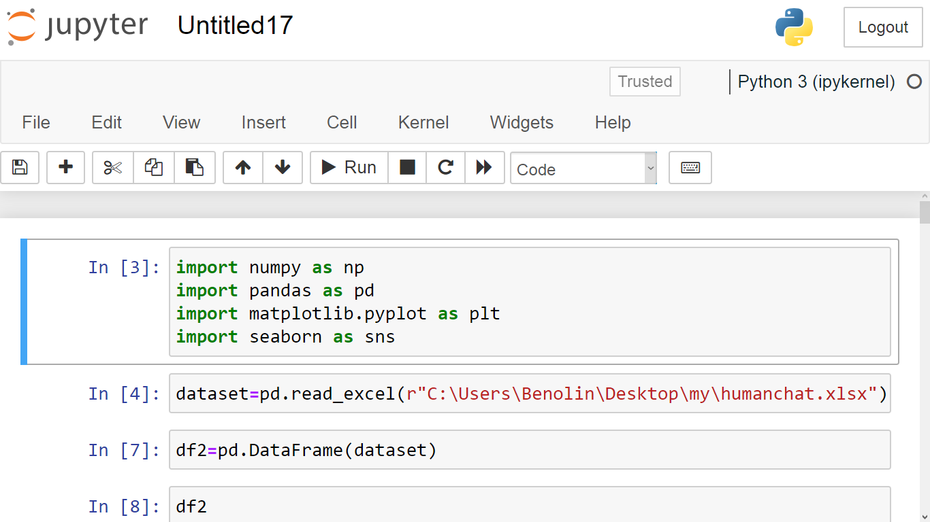

Explanation:

Pandas:

It's a powerful data manipulation and analysis library. It provides data structures like DataFrames to efficiently work with structured data, perform data cleaning, filtering, and aggregation operations.

Numpy:

It's a fundamental package for scientific computing in Python. It provides support for large, multi-dimensional arrays and matrices, along with a collection of mathematical functions to operate on these arrays.

Matplotlib:

It's a popular plotting library that allows you to create a wide range of visualizations, including line plots, scatter plots, bar plots, histograms, and more.

#load the dataset:



This code reads contents of a excel file called "humanchat" and saves it a variable called"dataset"The "pd" modul is already imported.

#DataFrame:

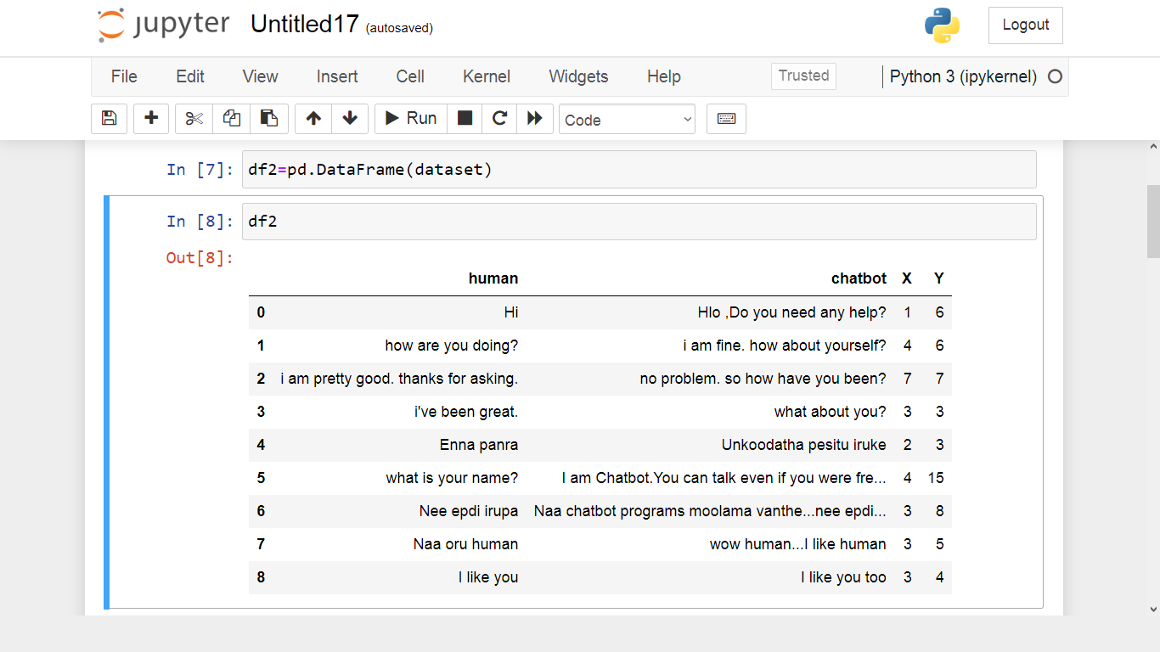

The code creates a new DataFrame called df2 by copying the contents of an existing DataFrame df1. The pd.DataFrame() function is used from the `pandas library to create the new DataFrame.

#Histogram:

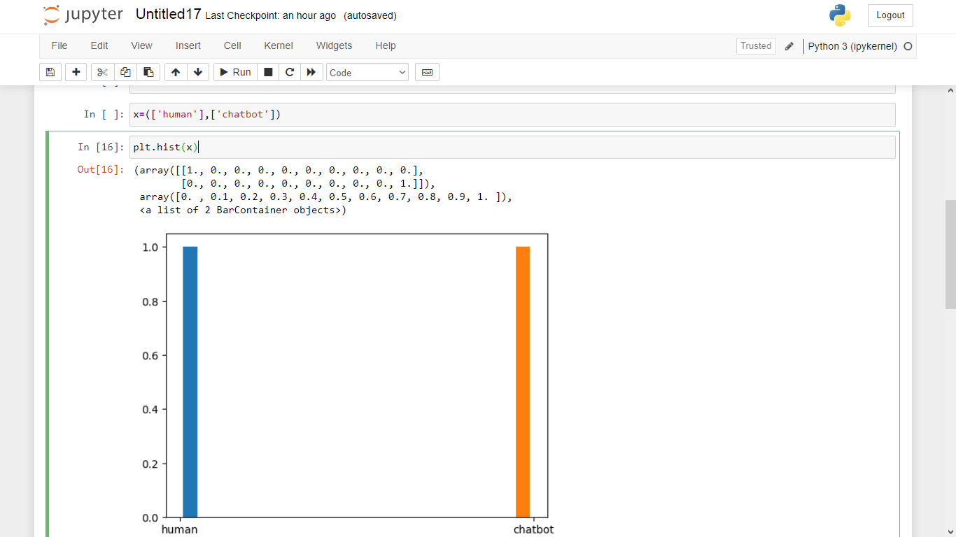

This python code reads the human and chatbot conversions from a dataframe.If then create a Histogram plots.

#Scatterplot:

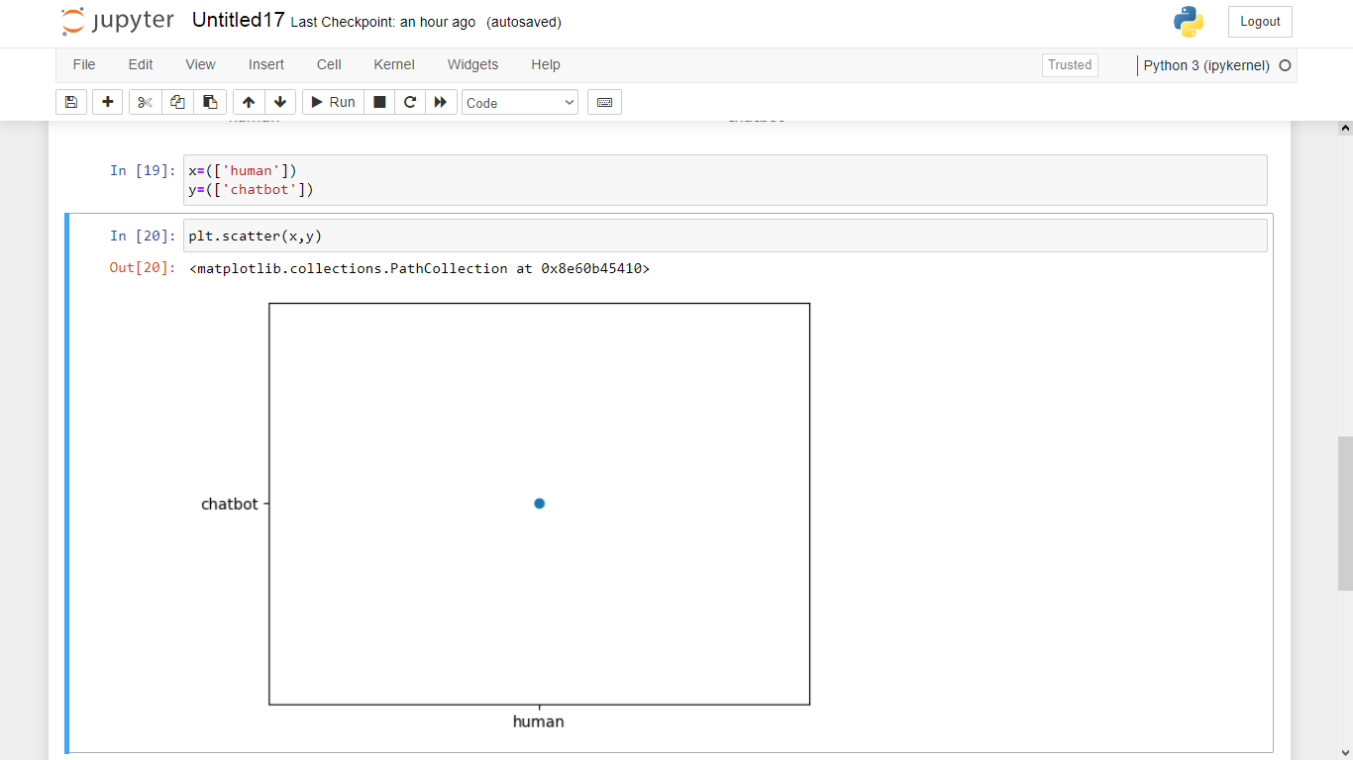

The plt.scatter() function is used to create the scatter plot,x-axis to human and y-axis to chatbot.

#Plotter:

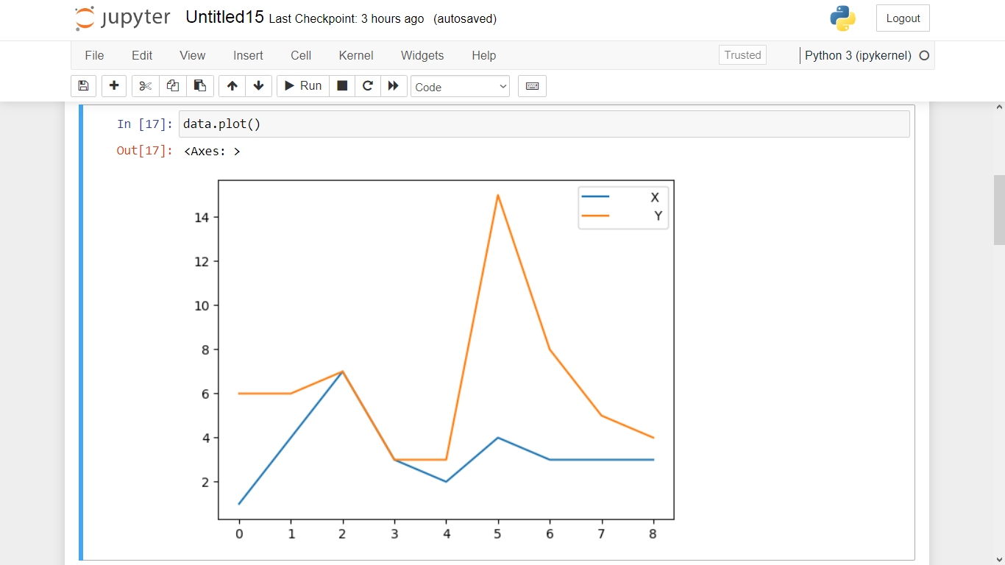

The plot can be used to human chat in dataframe used in x-axis and y-axis.

#Box Plot:

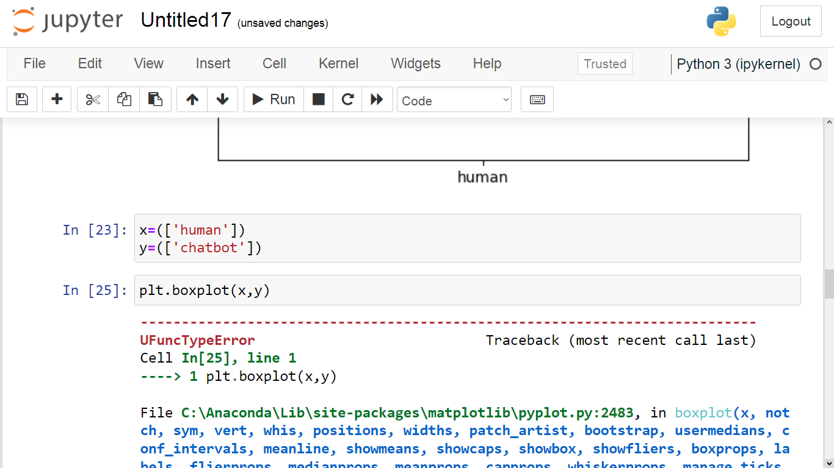

Output

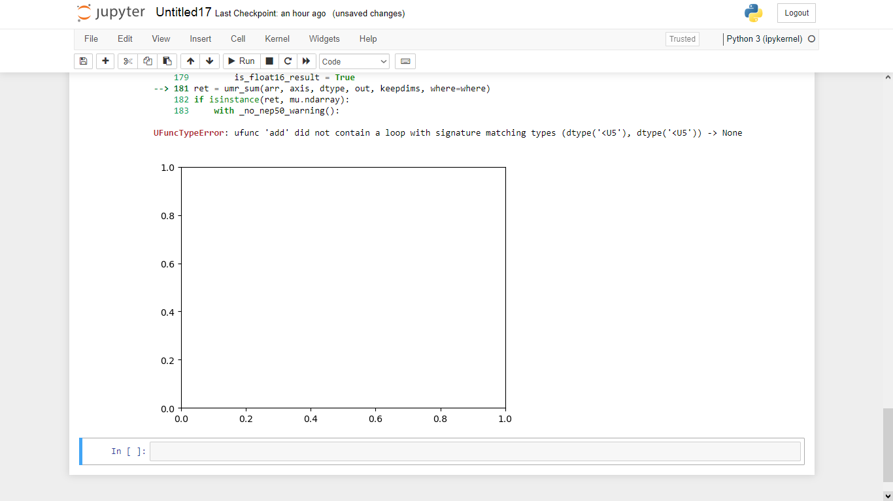

The code is using the pandas library to create a box plot in a DataFrame called 'df'. It the plot using the plt.show() function from the matplotlib library.